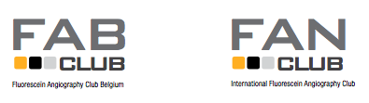

REGISTRATION
Deadline April 15

FAB I FAN Club meeting
Ghent, Belgium, Saturday May 13, 2017

Name: Mr/Mrs...

E-mail: ...

Tel: ...

- Will you present a case?
YES / NO

- USB-stick or Mac? (if Mac, please bring connecting cable)
...

- Will you join for an one hour boat trip in Ghent city center on Saturday afternoon after the meeting? Offered by FAN
YES / NO -- with partner? YES / NO

- Will you join for dinner in Ghent at 19:30 ? Offered by FAN
YES / NO -- with partner? YES / NO (charge for partner of 75 EUR because of regulations)

- Dietary restrictions?
...

Please return this Registration Form not later than April 15, to Marlene Verlaeckt mv@mecodi.eu

Thank you!

